(Aage) Tom Kristensen (August 4, 1893 in London, UK – June 2, 1974 on Thurø, Denmark)

Tom Kristensen was the most influential exponent of expressionism in 1920s Denmark. During this period he wrote both poetry and novels that gave voice to this new literary current. After 1930 Kristensen wrote almost solely commemorative and occasional poems. In addition to these works, Kristensen was a productive and influential literary critic and essayist. Kristensen was deeply influenced by figures such as Johannes V. Jensen, D.H. Lawrence, and James Joyce.

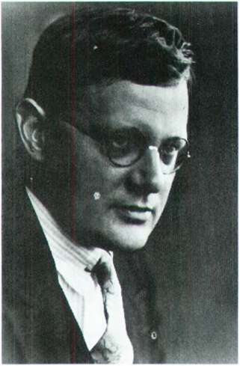[ [http://www.denstoredanske.dk/@api/deki/files/82689/=bd-12-214.jpg]

Just as his contemporary Emil Bønnelycke, Tom Kristensen was inspired by German expressionism. He made his debut with the collection of poems Fribytterdrømme (1920), a central work of expressionist poetry in Denmark. The word ‘drømme’ [dreams] in the title already indicates the work’s expressionist nature: The exotic places described in the poems were not familiar to Kristensen, but rather served as colorful and sonorous scenarios (as in the poem “Rio de Janeiro”). The central poem of the collection is the revolutionary “Landet Atlantis” (“A Land Called Atlantis”). Although it is inspired by the Russian and German revolutions, the Atlantis/Utopia of the poem should be read as an aesthetic rather than a political message. The poem’s language and gestures are indebted to Nietzsche’s Dionysian aesthetics, but the text also demonstrates the general discrepancy in the poetry of Kristensen between a disharmony described at the level of content and the strictness of form that actually represents it: the poem refers to a decomposition of forms, but it does not follow its own program. This is also true of “Itokih!,” which takes Dadaistic pleasure in the sounds of the Maori language, but only as an exotic refrain in an otherwise metrical poem. No other Danish poet, however, more successfully achieved the expressionist vision of beauty beyond harmony than Tom Kristensen did.
In the 1920s, Kristensen wrote three more collections of poetry: Mirakler (1922) continued the expressionist style of his earlier work, Paafuglefjeren (1922) was inspired by his journey to China, and his Verdslige Sange (1927) praises erotic feeling.
Kristensen also wrote three novels and a travelogue during the 1920s: the dystopian Livets Arabesk (The Arabesque of Life, 1921), the psychological exploration En anden (1923), the expressionist travel account En kavaler i Spanien (1926), and the modern classic Hærværk (Havoc, 1928). En anden and Hærværk were inspired by Joyce’s stream of consciousness technique. (In 1931, Kristensen famously reviewed Ulysses, and during his stay in Copenhagen in 1936, Joyce met Kristensen). Havoc describes the collapse of the journalist Ole Jastrau who – feeling trapped by the routine of his bourgeois life – decides to abandon his job and family in order to “go to the dogs”. The main character longs for a catastrophe as a way of realizing his deepest spiritual self. Thematically, Havoc sums up Kristensen’s earlier works, but at the same time it leads to a criticism of what Kristensen perceived as expressionism’s aesthetic nihilism. After Havoc Kristensen remained an important voice in the cultural life of Denmark, but mainly as a critic and essayist. Despite Kristensen’s later aesthetical self-criticism and political engagement, his main achievement as an author lies in his expressionist literary production in the 1920s.

Selected Works
Novels
Livets arabesk (1921)
En anden (1923)
Hærværk (1930)

Poems
Fribytterdrømme (1920)
Paafuglefjeren: digte fra Kina (1922)
Verdslige sange (1927)

English Translations
Havoc. Transl. by Carl Malmberg. Madison/London: University of Wisconsin Press 1968.
“The Land called Atlantis. A Symbol”, in: Danish Literary Magazine. Vol. 5 (1993). Transl. by W. Glyn Jones, p. 15.

Further Reading
Byram, Michael S.: Tom Kristensen. Boston: Twayne Publishers 1982.

Internet Resources
Klaus Rifbjerg on Tom Kristensen: http://www.danskedigtere.sdu.dk/riftk.html
Tom Kristensen on Danish Television (1962): http://agent.dril.dk/agent/?media=2713<8&style=undervisning

